Guidelines for working near water and sewer infrastructure
07 November 2016

Does this document apply to me?
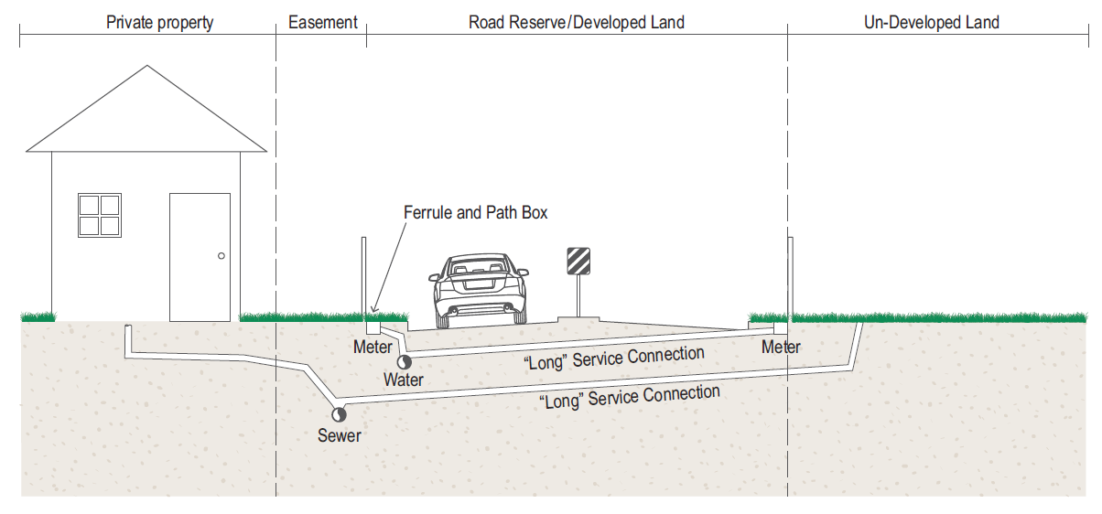

Refer to City of Gold Coast Network Modifications Extension and Connections (NMEC) Policy Procedure* | Continue reading this document | Refer to the SEQ Code*
*For instances where there are conflicts outside of the road reserve / developed land, the principles and protocols stipulated in this guideline will still apply.
What do I have to do?
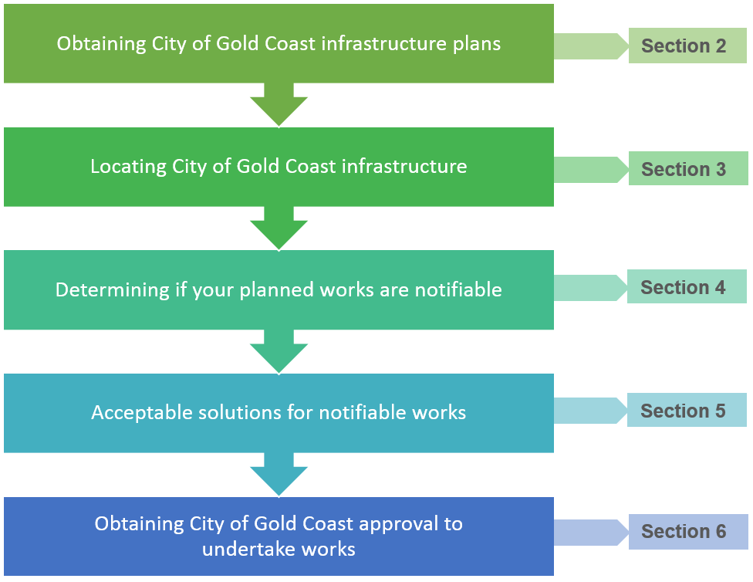
Table of Contents
1. General information 5
1.1 Background 5
1.2 Purpose 5
1.3 Protection of other City infrastructure 5
1.4 Duty of care 5
1.5 Legislative requirements 6
1.5.1 State controlled roads 6
2. How to obtain City water and sewer infrastructure plans 7
2.1 Public utility service providers 7
3. Locating City’s existing water and sewer infrastructure, what do we require? 8
3.1 Corrections to City’s data 9
3.2 Discovering unacceptable separation between City infrastructure and other services 9
4. What are notifiable works? 10
4.1 Excavation works above City water and sewer infrastructure - temporary 11
4.2 Excavation works next to City water and sewer infrastructure – temporary 12
4.3 Excavation works under City water and sewer infrastructure 13
4.4 Excavation works behind thrust blocks – temporary 14
4.5 Vibration compaction above, under and next to City water and sewer infrastructure 15
4.6 Changes to surface levels - permanent 16
4.6.1 Decrease in surface level 16
4.6.2 Increase in surface level 17
4.6.3 Adjustment of surface infrastructure (e.g. hydrants, valves, meter boxes, maintenance holes) to match change of ground level 18
4.7 Change of land use – temporary and permanent 19
4.7.1 Installation of new concrete footpath / widening of existing footpath 19
4.7.2 Change from verge or park to road – permanent / road-widening 19
4.7.3 Change from grass verge or park to road - temporary 20
4.7.4 Change of grass verge or park use – temporary site compound, storage and lay down 20
4.7.5 Drainage outlet (headwall) location 21
4.7.6 Designated water ways and drains 21
4.8 Piling next to City water and sewer infrastructure 22
4.9 Planting of trees near City water and sewer infrastructure 23
4.10 Steel pipelines and induced stray currents 23
5. Acceptable solutions for notifiable works 24
5.1 Step 1: Can the proposed works be re-designed to eliminate working within the notifiable zone, or to avoid a notifiable activity? 25
5.2 Step 2: Can the existing water and sewer infrastructure be modified to enable working within the notifiable zone? 25
5.2.1 Modification standards 25
5.2.2 Acceptable modification outcomes 25
5.2.3 Specific modification requirements 26
5.3 Step 3: Protect existing water or sewer infrastructure to enable working within the notifiable zone 27
6. How to obtain City approval 28
6.1 Conflict assessment and resolution 28
6.2 Notification to the City 28
6.2.1 Timeframe for notification 28
6.3 Approval of solution 29
6.4 Typical approval conditions 29
6.4.1 Dilapidation assessment 29
6.4.2 Sewer failure impact assessment 29
6.4.3 Electrical or gas infrastructure over City water and sewer infrastructure 29
6.5 Damage of water and sewer infrastructure during construction 30
Appendix A – Typical City water and sewer infrastructure 31
Appendix B – Example conflict register 32
Appendix C – Application to undertake notifiable works 33
Appendix D – Typical leak detection procedure 34
Appendix E – Typical approval conditions drawings 35
Appendix F – List of acronyms 36
Appendix G – List of definitions 37
Appendix H – Document control form i

General information

Background
As our roads become increasingly congested, construction works are more frequently occurring within the area of influence of City of Gold Coast (City) water and sewer infrastructure. Adverse impacts to our infrastructure often inhibits our ability to adequately service the community safely, sustainably, and with due consideration of the environment.
This has created a need for additional guidance in collaboration with the SEQ Design and Construction Code (SEQ Code) to ensure that the existing City water and sewer infrastructure is protected as our city grows.

Purpose
The purpose of this guideline is to provide a reference for Stakeholders (i.e. Contractors, Supervisors, Project Managers, Designers, etc.) when planning or undertaking works on public property (Off Lot) within the vicinity of City water and sewer infrastructure (including property connections - refer Appendix A). The guideline will assist Stakeholders when preparing to undertake works near City water and sewer infrastructure to ensure this infrastructure is protected.
The City authorises the Applicant to prepare a Registered Professional Engineer Queensland (RPEQ) certified detailed design for works that impact City water and sewer infrastructure in accordance with minimum requirements stated in this document and other relevant standards.
- The City will review the proposed works and RPEQ certified designs for the protection of City water and sewer infrastructure and will hold the Stakeholders accountable for the identification, management, and protection of this infrastructure where works are planned or undertaken within the area of influence.
- Stakeholders directly associated with the on-site component of works are responsible for the equipment and methods that are used
- This guideline provides guidance with respect to construction activities and methodologies that impact existing infrastructure and advises appropriate and acceptable outcomes to reduce these risks.
Furthermore, it is the responsibility of all Stakeholders involved in planning or undertaking the works to ensure the integrity of existing infrastructure is maintained.

Protection of other City infrastructure
This guideline is specifically relevant to the protection of City water and sewer infrastructure in public property and does not detail requirements or works required for protection of other City infrastructure, such as:
- Stormwater and drainage infrastructure.
- Road lighting infrastructure.
- Traffic signal, Intelligent Traffic Systems (ITS) and control infrastructure.
- Communications (CCTV and optic fibre) infrastructure.
- Other Utilities service provider’s infrastructure.

Duty of care
It is the responsibility of the relevant parties to embrace a duty of care to ensure that works within the vicinity of City water and sewer infrastructure do not affect its operational capacity or life expectancy and that the proposed design and construction works are undertaken in accordance with the relevant Queensland Work Health & Safety and Environmental Protection legislation.
While the City will provide assistance in the form of plans, or information, it is ultimately the responsibility of the party conducting the works to actively verify the location of all existing water and sewer infrastructure via potholing and to ensure that the works do not interfere with existing City water and sewer infrastructure.
Should City water and sewer infrastructure be inadvertently exposed or damaged during construction works, all works must cease immediately and the site must be made safe. City of Gold Coast (1300 000 928) must be contacted immediately. Once the City has been notified, you must then immediately contact the relevant Asset Conflict Officer.
It is the responsibility of the relevant parties to ensure operational functionality and safe access to City water and sewer infrastructure at all times while undertaking works above, under or next to City water and sewer infrastructure.

Legislative requirements
Gold Coast Water and Waste (GCWW) is a business unit of the City. GCWW is a water service provider and a sewerage service provider for the purposes of the Water Supply (Safety and Reliability) Act 2008 (Qld) (Water Supply Act).
The purpose of the Water Supply Act is to provide for the safety and reliability of water supply. The Water Supply Act seeks to achieve this purpose by regulating the provision of water and sewerage services in the State, including by prescribing the functions and powers of service providers. Relevantly, the Water Supply Act:
- Gives a service provider specific powers to enable the service provider to protect its infrastructure.
- Makes it an offence for a person to interfere with a service provider's infrastructure without approval.
- Prescribes significant penalties for offences under the Act.
Section 192(1) of the Water Supply Act makes it an offence for a person to interfere with a service provider's infrastructure, without the service provider's written consent.
Section 192(2) of the Water Supply Act makes it an offence for a person to build over, interfere with access to, increase or reduce the cover over, or change the surface of land in a way causing ponding of water over an access chamber for, a service provider's infrastructure, without the service provider's written consent.
Section 192(3) of the Water Supply Act provides that, despite ss. 192(1) and (2), a person does not require the written consent of the service provider if the person carries out building work for a building or structure on a lot that contains, or is adjacent to a lot that contains, a sewer or water main of the service provider.
Note: For s. 192(3) above, all works planned or undertaken on private property must comply with the relevant sections of the Queensland Development Code and the City’s Network Modifications, Extension and Connections Policy Procedure.
Note: An offence under s. 192(1) and s. 192(2) of the Water Supply Act is an infringement notice offence under the State Penalties Enforcement Act 1999 (Qld) and associated regulations. An authorised person of the City may issue a PIN (i.e. a prescribed infringement notice) in respect of an offence under s. 192(1) and s. 192(2) of the Water Supply Act.

State controlled roads
City water and sewer infrastructure is "public utility plant" within the meaning of the Transport Infrastructure Act 1994 (Qld) (Transport Infrastructure Act). The Transport Infrastructure Act applies:
- Where the Council is constructing, augmenting, altering or maintaining public utility plant on a State-controlled road.
- More generally, if the Department of Transport and Main Roads (Department) wishes to impose requirements around public utility plant on a State-controlled road, including the relocation of public utility plant.
Whether, and to what extent, this Guideline will apply to work undertaken by the Department near City water and sewer infrastructure will depend on the requirements (if any) imposed by the Department in accordance with the Transport Infrastructure Act.

How to obtain City water and sewer infrastructure plans
WARNING: City of Gold Coast is NOT a member of Dial Before You Dig (DBYD), as such City water and sewer infrastructure plans must be obtained by submitting the following to the City of Gold Coast:
- City of Gold Coast Search Request form. This can be downloaded from the City of Gold Coast website by typing “Search Request Form” into the search bar and following the links to the Mapping searches page.
Or/and
- City of Gold Coast Sewerage Infrastructure Drawing Request Form.
WARNING: While the City endeavours to provide the most accurate and up to date infrastructure plans, all information provided by us is required to be verified on site by the Project Stakeholder at their cost.
Other utility service provider's infrastructure data and requirements can be obtained by submitting an application on the DBYD website www.1100.com.au or by phone on 1100.

Public utility service providers
Public utilities may submit a “Utilities location mapping request form” to acquire water and sewer asset location information within the City. There will be no fee for public utilities utilising this service. Please contact City of Gold Coast Conflicts Office on 1300 000 928 for a copy of the form.

Locating City’s existing water and sewer infrastructure, what do we require?
The City understands that the accuracy of the service location data should be in line with the phase of the project. Table 3.1 identifies the City’s requirements for service location data accuracy at each phase of the project. All applications should comply with these minimum quality levels stipulated in Table 3.1.
Quality levels have been extracted from AS 5488 and are defined within Table 3.2.

Table 3.1: Minimum required infrastructure location quality level
Project phase | AS 5488 Quality levels
Planning | D or better
Detailed design | A or better
Construction | A or better

Table 3.2: Excerpt from SEQ Code – Definition of Quality levels
Quality level | Information sources / survey requirements | Horizontal tolerance | Vertical tolerance
D | Existing records, cursory site inspection, anecdotal evidence. | N/A | N/A
C | As for D plus site survey of visible evidence that may use relative or absolute positioning. | +/- 300 mm | N/A
B | As for C, but must include a survey of both the surface and buried features. Buried features of existing infrastructure may be carried out by no-dig survey techniques. | +/- 300 mm | +/- 500 mm
A | Positive identification of attributes and the absolute location of subsurface and surface features in three dimensions. | +/- 50 mm | +/- 50 mm
A+ | Positive identification of attributes and the absolute location of surface & subsurface features in three dimensions.  - Locations between potholes must not span longer than 10 metres, closer when and where necessary at bends/change in direction.  - Where other underground infrastructure crosses another, another reading is required at that location. | +/- 50 mm | +/- 10 mm

The Project Stakeholder will be requested to provide evidence of their investigations to confirm the location of City water and sewer infrastructure. This evidence should include survey data capture of the services located, as well as long section plans for City water and sewer infrastructure affected by the notifiable works. Long section plans are to show the existing surface level, cover over mains, and the proposed Finished Surface level (FSL) for all existing City water and sewer infrastructure.
Refer to Appendix C for supporting information to be provided with each application where notifiable works (per Section 4 of this guideline) are proposed.

Corrections to City’s data
In order to continue to improve the accuracy of City’s GIS data, the City encourages all Project Stakeholders to advise the City of all discrepancies found in regards to the following information:
- Material type.
- Pipe or maintenance hole diameter.
- Asset location, i.e. valve, fire hydrant, pit, water meter and maintenance hole, etc.

Discovering unacceptable separation between City infrastructure and other services
If City water and sewer infrastructure is uncovered with clearances to other services that are not compliant with the SEQ Code, then the Project Stakeholder must notify the City of Gold Coast (1300 000 928), so the conflict can be captured and the appropriate corrective action undertaken by the City.

What are notifiable works?
This section of the Guidelines illustrates when the City is required to be notified of the proposed works ‘above’, ‘under’ and ‘next to’ City water and sewer infrastructure.
Application to the City for approval is not required, proceed with works.
NOTIFIABLE WORKS: Application must be submitted to the City for approval prior to commencing works. It should be noted that timely applications to the City will reduce the chance of delays to your project.

NOTE: Works that are NOT deemed notifiable may still require acceptable solutions as detailed in Section 5 of this document.

NOTE: If for any reason your proposed works do not fall into any of the scenarios detailed in Section 4, you must contact the City before any works commence.

Excavation works above City water and sewer infrastructure - temporary
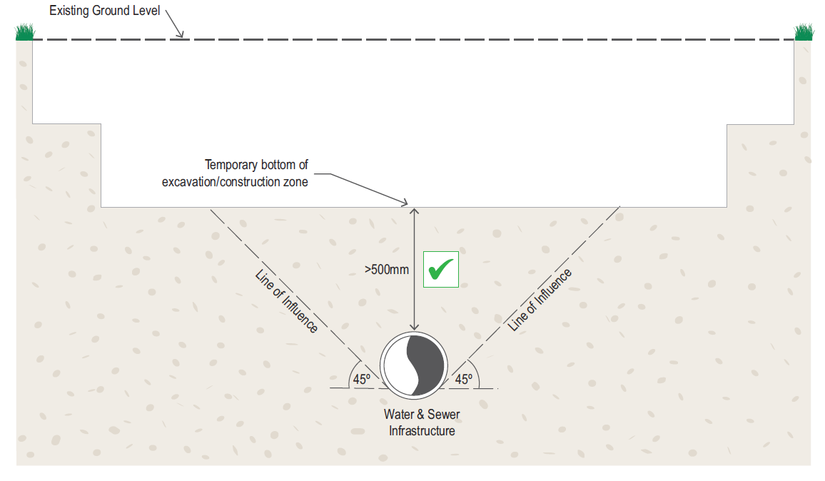
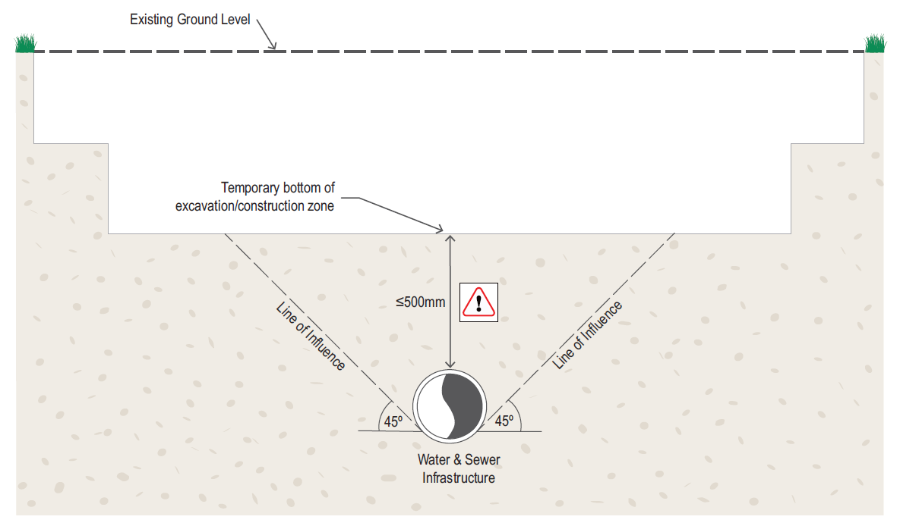

Excavation works next to City water and sewer infrastructure – temporary
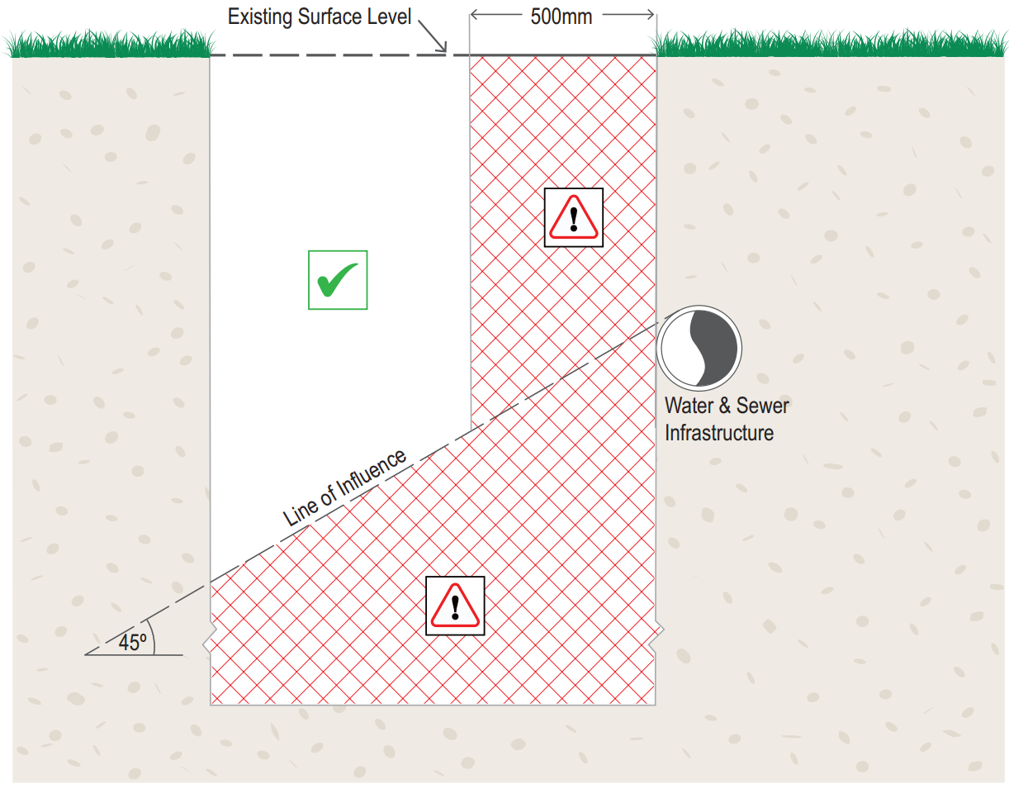
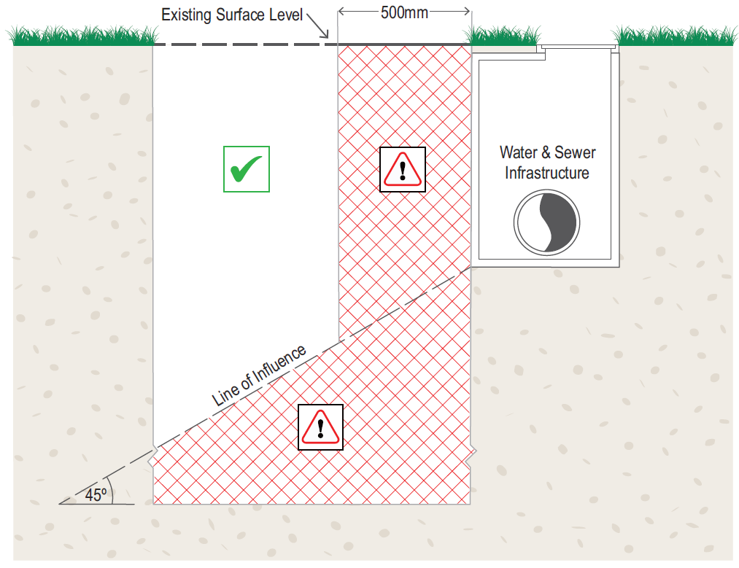
Note: angle of repose is dependant of soil type and water table height. Applicant should determine angle of repose prior to submission of application.

Excavation works under City water and sewer infrastructure
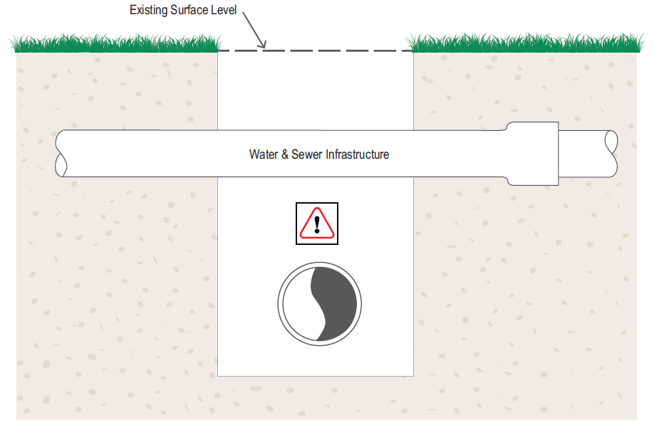
Note: All open excavation works under water and sewer infrastructure are notifiable works.
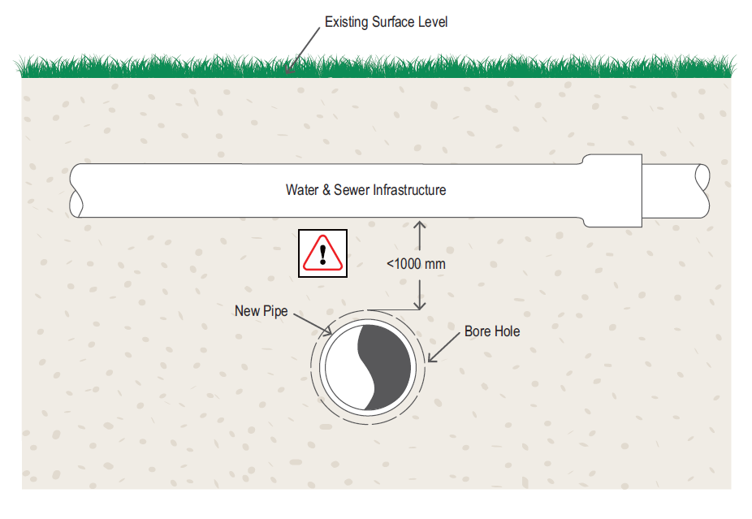
Note: Any under-boring works within 1000mm of water and sewer infrastructure are notifiable works.

Excavation works behind thrust blocks – temporary
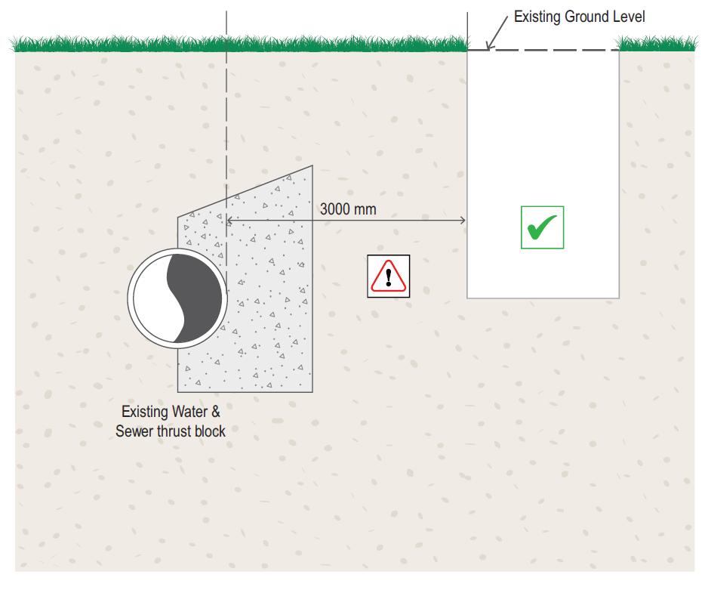
Note: For pipelines greater than 300 millimetres in diameter, all excavation works up to 5 metres behind thrust blocks are notifiable works.

Vibration compaction above, under and next to City water and sewer infrastructure
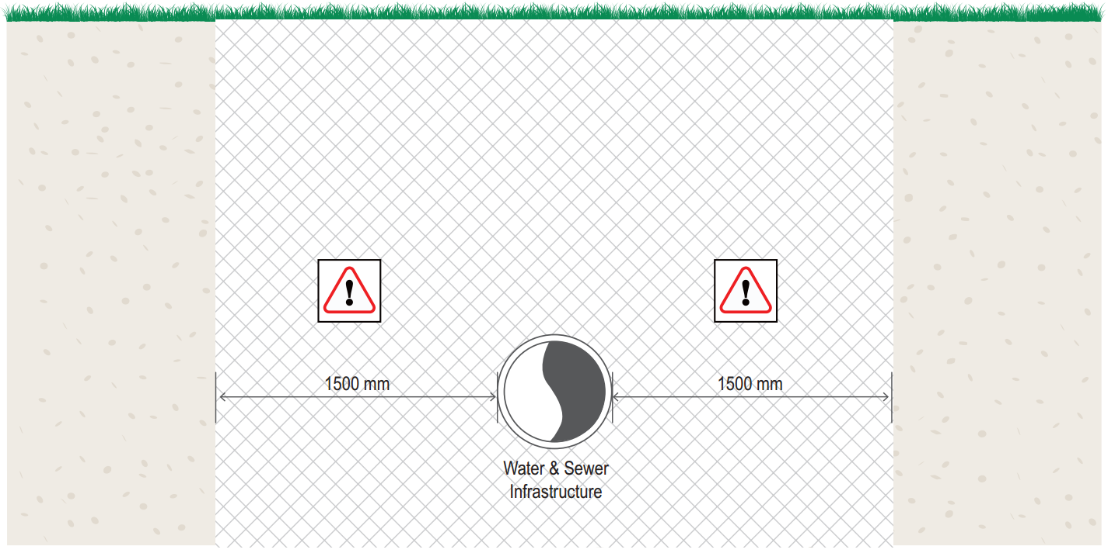

Changes to surface levels - permanent
The following section outline’s scenarios involving either temporary or permanent changes to surface levels above City water and sewer underground and/or surface infrastructure:

Decrease in surface level
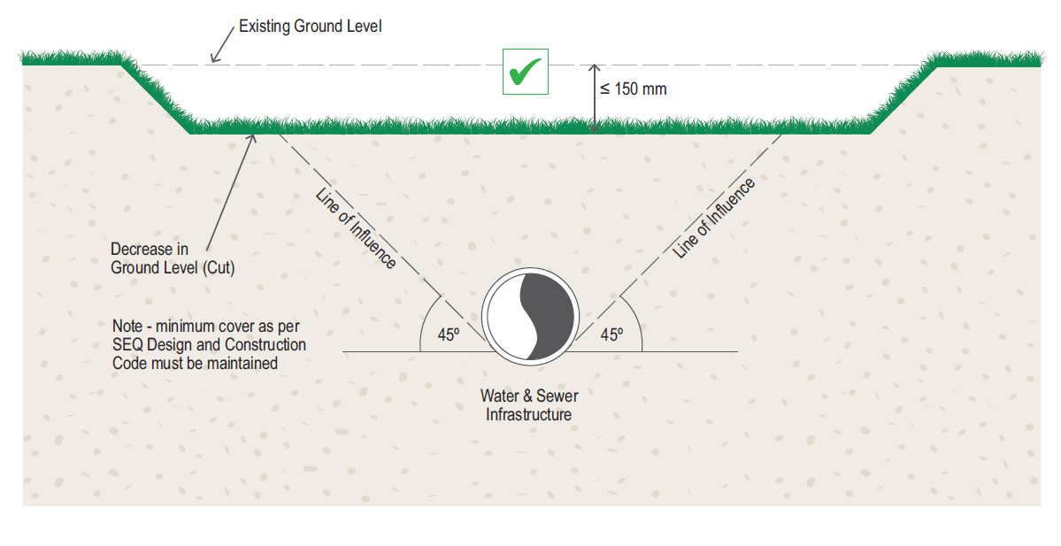
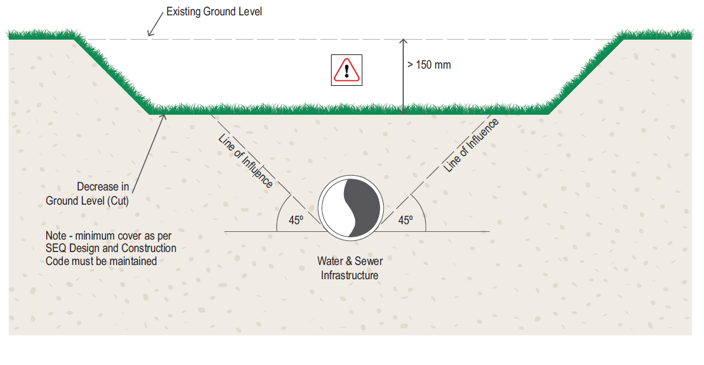

Increase in surface level
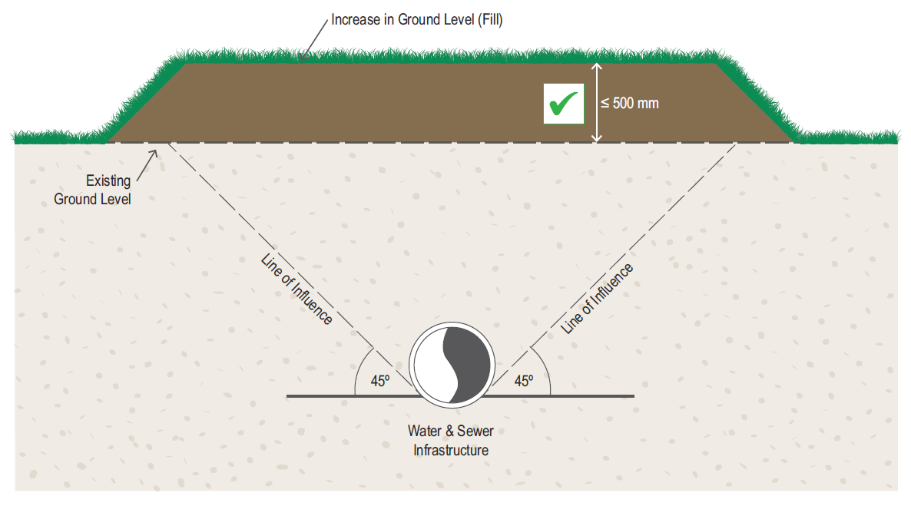
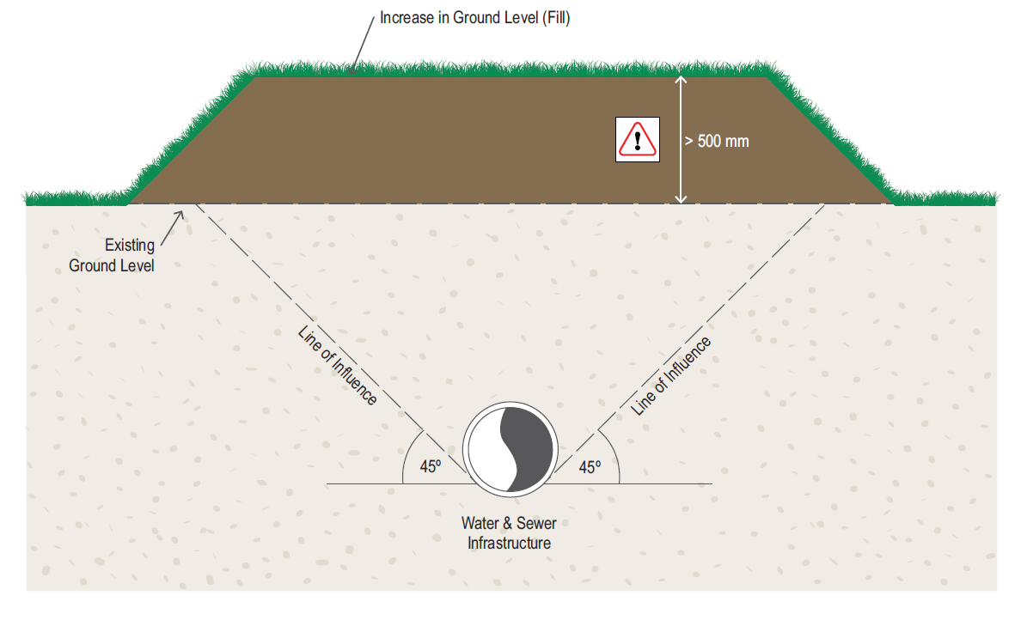

Adjustment of surface infrastructure (e.g. hydrants, valves, meter boxes, maintenance holes) to match change of ground level
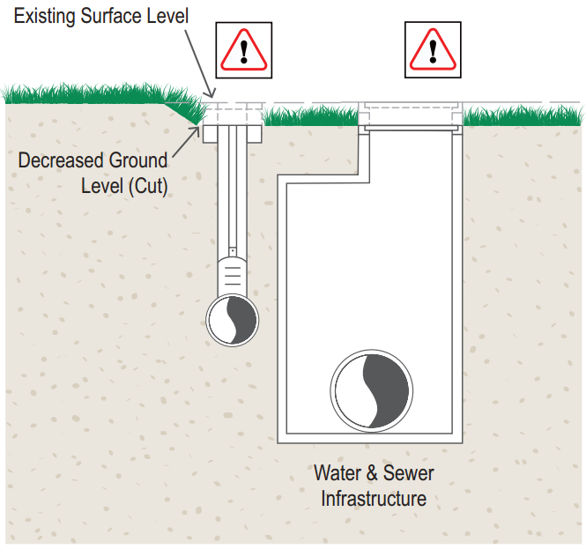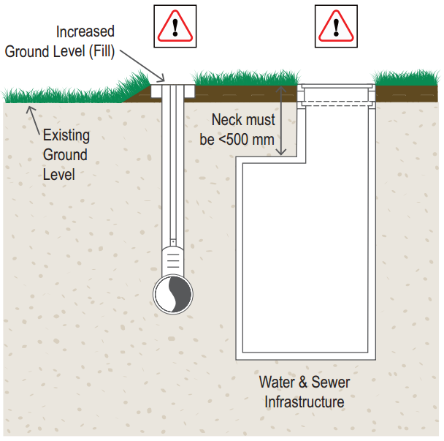

Change of land use – temporary and permanent
The following section outline’s scenarios involving changes of land usage above City water and sewer underground and/or surface infrastructure:

Installation of new concrete footpath / widening of existing footpath
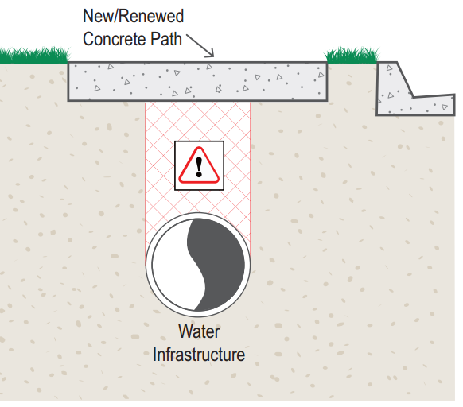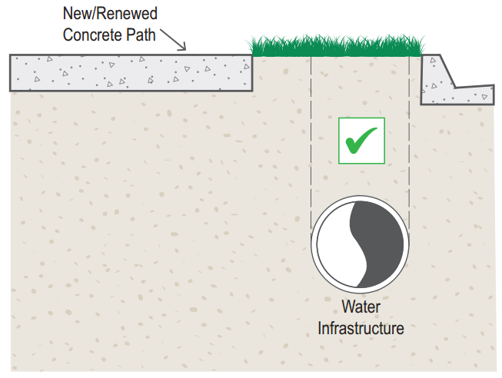

Change from verge or park to road – permanent / road-widening
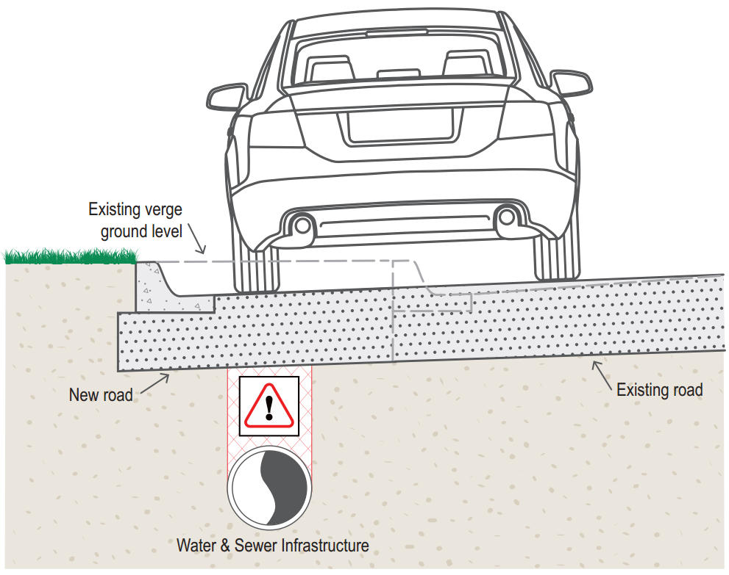

Change from grass verge or park to road - temporary
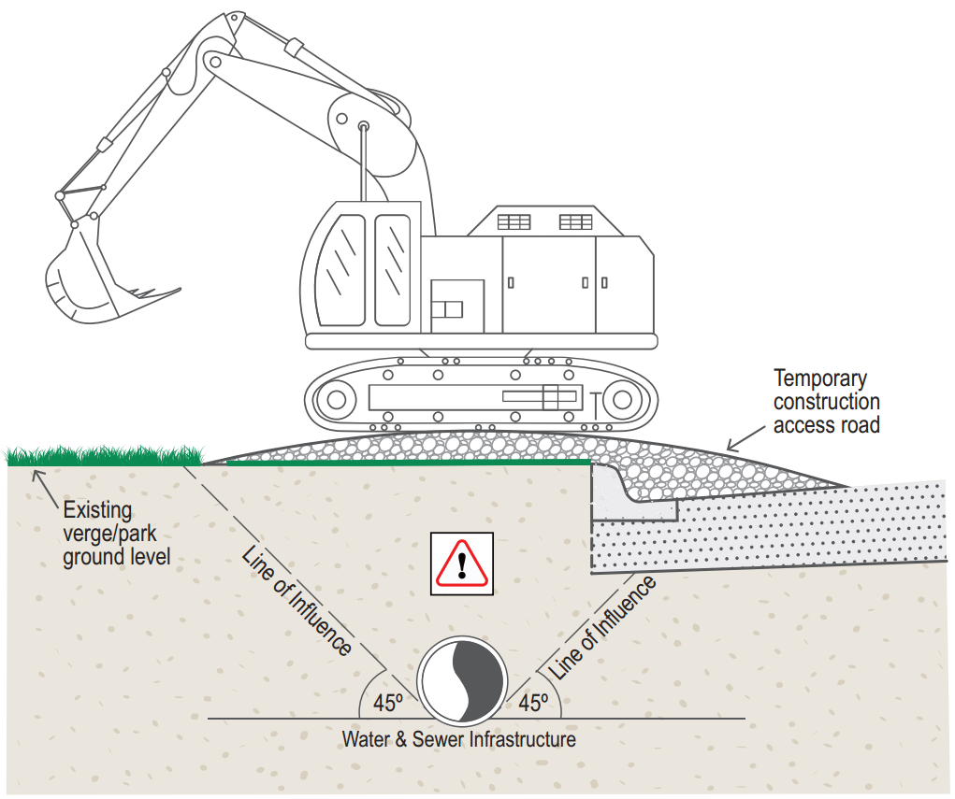

Change of grass verge or park use – temporary site compound, storage and lay down
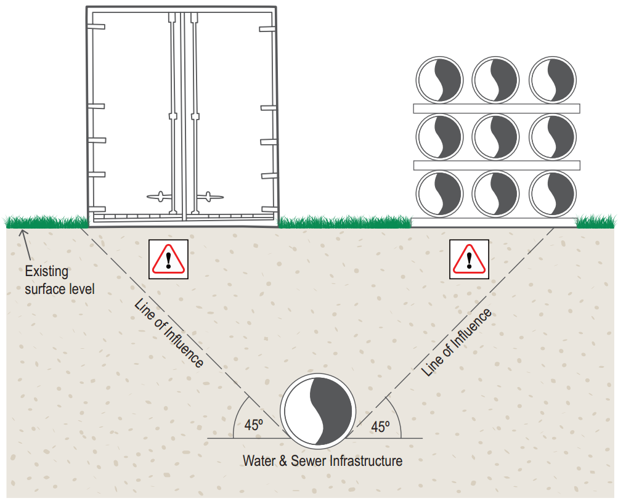

Drainage outlet (headwall) location
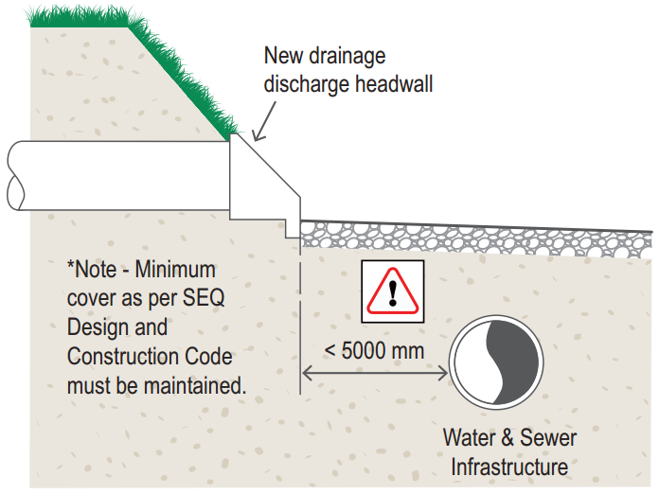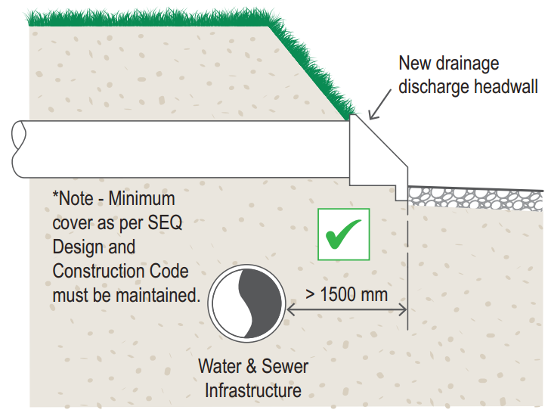

Designated water ways and drains
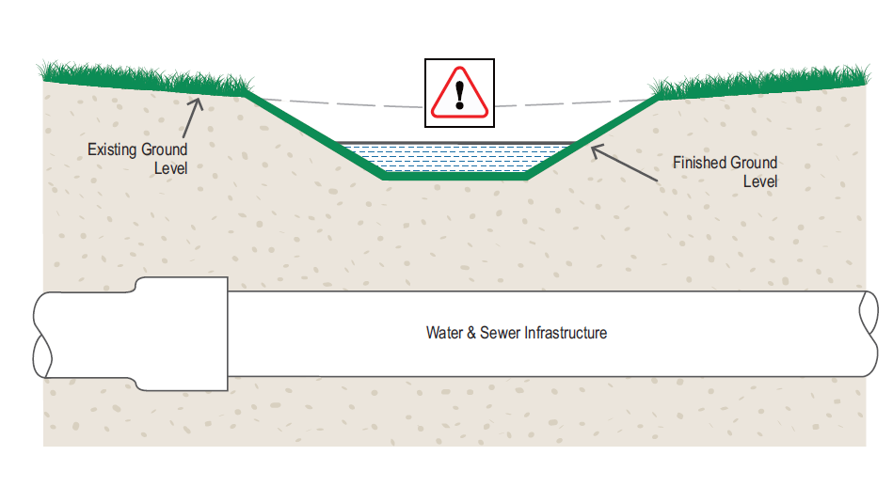
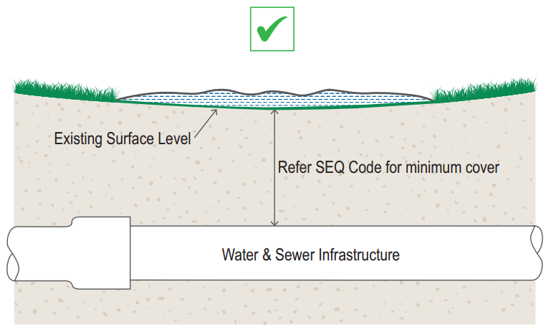

Piling next to City water and sewer infrastructure
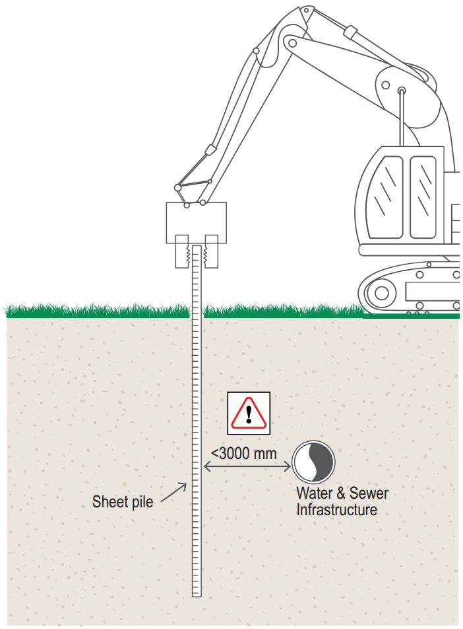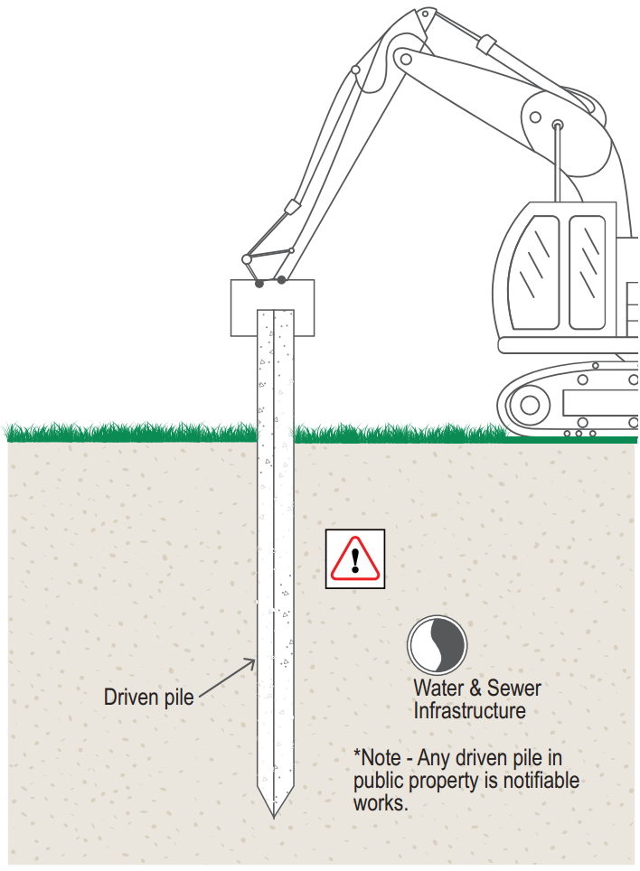

Planting of trees near City water and sewer infrastructure
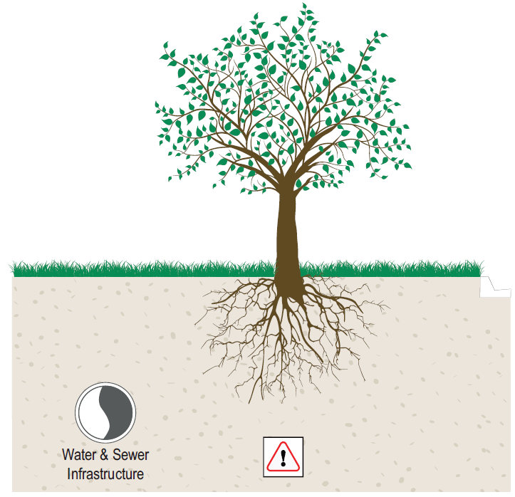

Steel pipelines and induced stray currents
Steel pipelines typically have continuity straps for cathodic protection. If the work involves electrical cables (underground or overhead) adjacent to steel pipes then induced currents need to be considered. In such a case a detailed assessment must be carried out by a specialist experienced in induction currents and safety risks.
Any proposed works within 25 metres of steel City water and sewer infrastructure, which may exhibit stray current, are notifiable works.

Acceptable solutions for notifiable works
Prior to submitting an application to the City for approval (refer Section 6 of this guideline), the Applicant shall undertake a review of the proposed works to develop an acceptable solution which is certified by an RPEQ that ensures City water and sewer infrastructure is not damaged or interfered with. The following process and flow diagram shall be adopted:
Step 1: Can the proposed works be re-designed to eliminate working in the notifiable zone, or to avoid a notifiable activity?
Step 2: Can the existing water and sewer infrastructure be modified to enable working within the notifiable zone?
Step 3: Protect existing water or sewer infrastructure to enable working within the notifiable zone. Please note that these are general protection measures that should be implemented to uphold a duty of care.
Note: To obtain formal written approval from the City, the Applicant must demonstrate that each Step has been followed sequentially and that preceding steps have been considered and are not practicable. Adequate justification supporting the Applicants claim that solutions in the preceding steps are not practicable must be submitted with the application for the City’s approval, refer to Section 6 of this guideline.
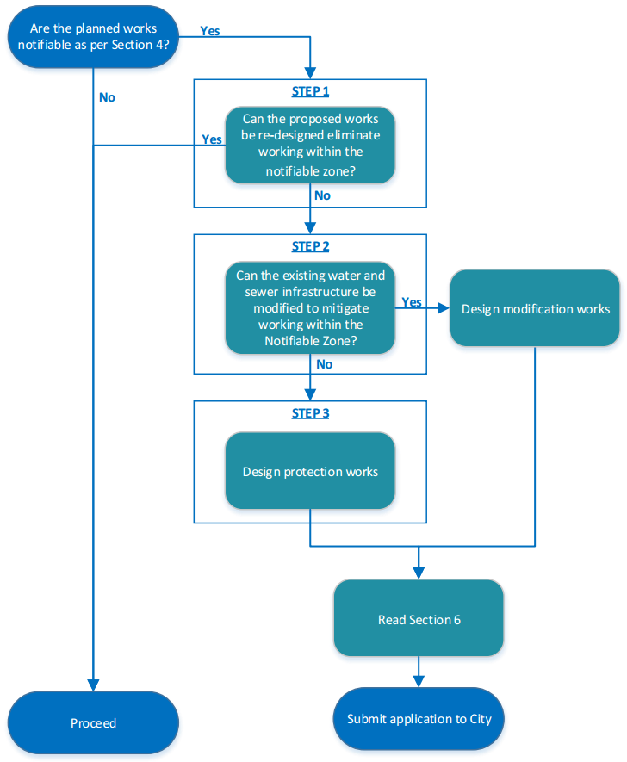

Step 1: Can the proposed works be re-designed to eliminate working within the notifiable zone, or to avoid a notifiable activity?
In the first instance, the proposed works should be analysed and redesigned/replanned to avoid works within the notifiable zones or to avoid a notifiable activity, as outlined in Section 4.
NOTE: If re-designing the proposed works is not a practicable outcome, your application must include adequate justification prior to proceeding to Step 2.

Step 2: Can the existing water and sewer infrastructure be modified to enable working within the notifiable zone?
This section identifies generally acceptable outcomes for modifying existing water and sewer infrastructure to mitigate impacts associated with third party works occurring within the notifiable zone. Project specific solutions are to be developed and subsequently certified by an RPEQ to expedite the approval process.
NOTE: If the identified modification outcomes are not practicable, your application must include adequate justification prior to proceeding to Step 3.

Modification standards
The full and comprehensive requirements of the SEQ Code should be followed when planning and designing modification works for the City’s water and sewer infrastructure. Instructions on how to find these requirements are provided below. Prior to submitting an Application to the City for assessment, the Applicant should:

Acceptable modification outcomes
The acceptable outcomes for modification of water and sewer infrastructure are as follows:
- Relocate water and sewer infrastructure outside of the notifiable zone in accordance with current standards and IPWEAQ standard drawings RS100 and RS101.
- Replace water and sewer infrastructure within the notifiable zone with approved material from the SEQ Code IPAM list.
- Reline sewer gravity mains from maintenance hole to maintenance hole and service connections from inspection opening to junction.
Where applicable, and possibly in conjunction with the above outcomes:
- Revise the City’s surface infrastructure to match the FSL of the proposed works and where appropriate reinstall identification markings.
If any of the above modification outcomes are proposed, please refer to Section 5.2.3 for specific modification requirements that may apply to certain outcomes in particular scenarios.

Specific modification requirements
Modification requirements for specific notifiable works scenarios that have been outlined within Section 4; are as follows:
Notifiable works scenarios | Section | Specific modification requirements
Excavation works under City water and sewer infrastructure | 4.3 | - If the main is to be replaced, it must be replaced a minimum of 1500mm from the edge of excavation and connected at the nearest joint. Refer Appendix E.
Changes to surface level – decrease in surface level | 4.6.1 | - Where existing water and sewer infrastructure does not have compliant cover and proposed works lower the existing surface level the existing infrastructure must be relocated.
Adjustment of maintenance holes and surface infrastructure | 4.6.3 | - 500mm maximum new neck length for maintenance holes for confined space requirements.
Change of land use – Installation of new concrete footpath /widening of existing footpath | 4.7.1 | - Installation of footpath ferrule boxes (Toby boxes) is required where concrete footpath is located above existing main.
Changing from verge or park to road - permanent | 4.7.2 | - Relocate water and sewer infrastructure outside of the road to provide safe and traffic free access.

Step 3: Protect existing water or sewer infrastructure to enable working within the notifiable zone
Protection requirements for specific notifiable works scenarios that have been outlined within Section 4; are as follows:
Notifiable works scenarios | Section |  | Specific protection requirements
Excavation works above City water and sewer infrastructure - temporary | 4.1 |  | - Concrete protection slabs are prohibited to be installed above the City water and sewer infrastructure.
Excavation works next to City water and sewer infrastructure | 4.2 |  | - Backfill must be designed to ensure the integrity of the City water and sewer infrastructure.
Excavation works behind thrust blocks | 4.4 |  | - Design of temporary support of the thrust block.
Vibration compaction above, under and next to City water and sewer infrastructure | 4.5 |  | - Use of self-compacting materials within the notifiable zone.  - Develop and implement construction methodology to use light machinery and low-vibratory construction techniques when compacting in the notifiable work zone.
Changing from grass verge or park to road - temporary |  | 4.7.3 | - Design construction access track to ensure that water and sewer is protected from traffic loading.  - City water and sewer surface infrastructure (i.e. valves, hydrants, meter boxes, scour chambers/outlets) must be temporarily made trafficable or relocated outside of the temporary access track.
Drainage outlet (headwall) location | 4.7.5 |  | - Install appropriate scour protection from headwall to downstream side of the City’s water and sewer infrastructure to prevent scouring and undermining of the water and sewer infrastructure.
Designated water ways and drains | 4.7.6 |  | - Drainage scour protection may be required to be installed to prevent scouring and undermining of the City’s water and sewer infrastructure.
Piling next to City water and sewer infrastructure | 4.8 |  | - Where practical redesign/replan the works to bench excavation instead of sheet piling.  - Sheet piling may be installed via hydro-excavation methodologies.  - Consider use of bored piles rather than driven pile in vicinity of City water and sewer infrastructure.  - In areas of low soil strength, consideration should be given to assessing pipelines further away from the works.
Planting of trees near City water and sewer infrastructure | 4.9 |  | - A root barrier should be installed.

How to obtain City approval

Conflict assessment and resolution
After validating the service location information, the Applicant should assess the severity of the conflict and develop a suitable solution in accordance with this document and the relevant specifications that eliminate and/or mitigate any interference with City’s infrastructure.
The City authorises the Applicant to prepare an RPEQ certified detailed design for the modification and protection works in accordance with minimum requirements stated in this document and the SEQ Code.

Notification to the City
Where proposed works meet the criteria outlined in Section 4 of this document, an application to undertake notifiable works must be submitted to the City (refer to Appendix C - Application to undertake notifiable works) via the following email address:
gcwconflictassessments@goldcoast.qld.gov.au
Applications to the City should address, but not be limited to the following:
- Identify all City water and sewer infrastructure in the works area.
- Identify all notifiable works (conflicts) between City water and sewer infrastructure and the proposed works. Refer Appendix B for an example Conflicts Register.
- RPEQ Certified Design Plans to mitigate or control the conflict between the proposed works and City water and sewer infrastructure.
- RPEQ Certified Construction Methodology to ensure the integrity of City water and sewer infrastructure during the works.
- Complete an application to undertake notifiable works (refer to Appendix C – Application to undertake notifiable works).

Timeframe for notification
Applications are divided into three (3) application types that determine the required information to be supplied and GCWW’s response.
Application Type | Anticipated time frame to start of works | Desired outcome
Planning & Concept | > 12 months | GCWW provide agreement of potential conflicts that require further investigation and resolution during detailed design phases
Detailed Design | 6 – 12 months | GCWW provides agreement to Applicant developed design for conflict resolutions
Construction & Emergent works | < 1 month | GCWW Inspectors attend site as required  WARNING: Failure to notify GCWW of works at prior phases of the project may result in delays to Construction.

Approval of solution
The City will review the Design Plans and Construction Methodology for the proposed service relocation and work in consideration of the type, material, age and reliability of the existing water and sewer infrastructure.
Following the City’s review of the Applicants submission, the City will provide a response in writing either approving the works, approving the works with conditions, or disapproving the submission and requesting that it be resubmitted to meet the requirements of this document and the SEQ Code.
As per legislation (refer Section 1.5) the Applicant must receive written consent from the City that the conflict solution is acceptable before the proposed works can proceed.
Note: the City will only consider non-compliant solutions once the Applicant has demonstrated that all compliant solutions are not feasible.

Typical approval conditions
The following section outlines typical conditions that may be requested by the City to obtain written approval.

Dilapidation assessment

Trunk mains
All pipelines >300 millimetre in diameter located within the construction footprint but not required to be relocated, shall be condition assessed pre and post construction where requested by the City. The assessment should determine if there is any existing cracking or loss of pipeline thickness or other pipeline weakness which may limit the pipeline’s life under the new conditions.

Pressure mains
Leak detection based on the typical procedure in Appendix D should be undertaken pre and post construction on pressure mains within the works area that are not to be relocated. Any damage to the main resulting from the works will be rectified at the Contractor’s expense.

Gravity mains
CCTV survey is to be conducted in conjunction with the City both prior to and post construction to ensure new works have not affected existing infrastructure. Any damage to the main resulting from the works must be rectified at the Contractor’s expense.

Surface features
Prior to commencing modification works, an inventory survey of all City water and sewer surface features (i.e. valves, hydrant lids, maintenance holes etc.) should be undertaken within the area of works. The City requires driveways and concrete footpaths to be constructed with a breakout box around City’s surface infrastructure, refer to standard drawings 11-145-1 and 11-145-2. For footpaths a control joint may be installed as per standard drawing IPWEAQ RS-065.
Access to surface infrastructure must be provided to the City at all times.

Sewer failure impact assessment
A sewer failure impact assessment (in accordance with Section 22 of WSA 02-2002-2.2) may be required by the City to be completed prior to commencing works above, below, and next to the City’s sewer mains.

Electrical or gas infrastructure over City water and sewer infrastructure
Where electrical or gas infrastructure is proposed to be installed over an existing City’s water or sewer main, additional marker tape must be installed on either side of the electrical or gas infrastructure to warn contractors doing excavation work on the City’s main that the electrical and gas services are present. Refer to Appendix E.

Damage of water and sewer infrastructure during construction
Should City water and sewer infrastructure be inadvertently identified within the notifiable zone, exposed or damaged during construction works; all works must cease immediately and the site be made safe. City of Gold Coast Conflicts Office (1300 000 928) must be contacted immediately.
Rectification works may include; but are not limited to:
- Relocation of City water and sewer infrastructure clear of the notifiable zone.
- Replacement of City water and sewer infrastructure with an approved material in accordance with the SEQ Code IPAM list.
- Replacement of a water service connection from the meter box to the ferrule in accordance with the SEQ Code.
- Replacement or relining of a sewer service connection from the reticulation main / manhole to the property boundary.

Rectification works and any associated damages will be investigated and may be the responsibility of the Applicant.

Appendix A – Typical City water and sewer infrastructure
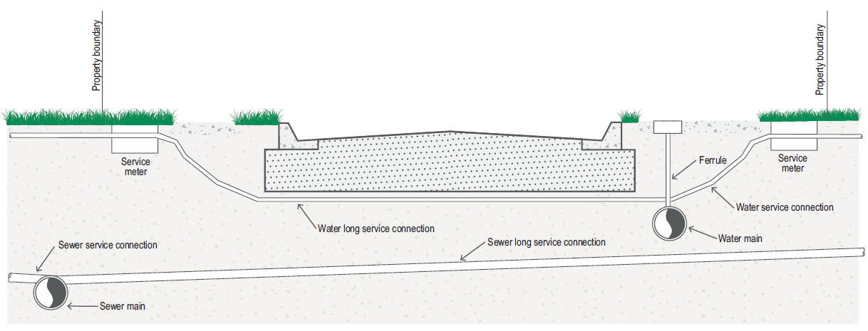

Appendix B – Example conflict register
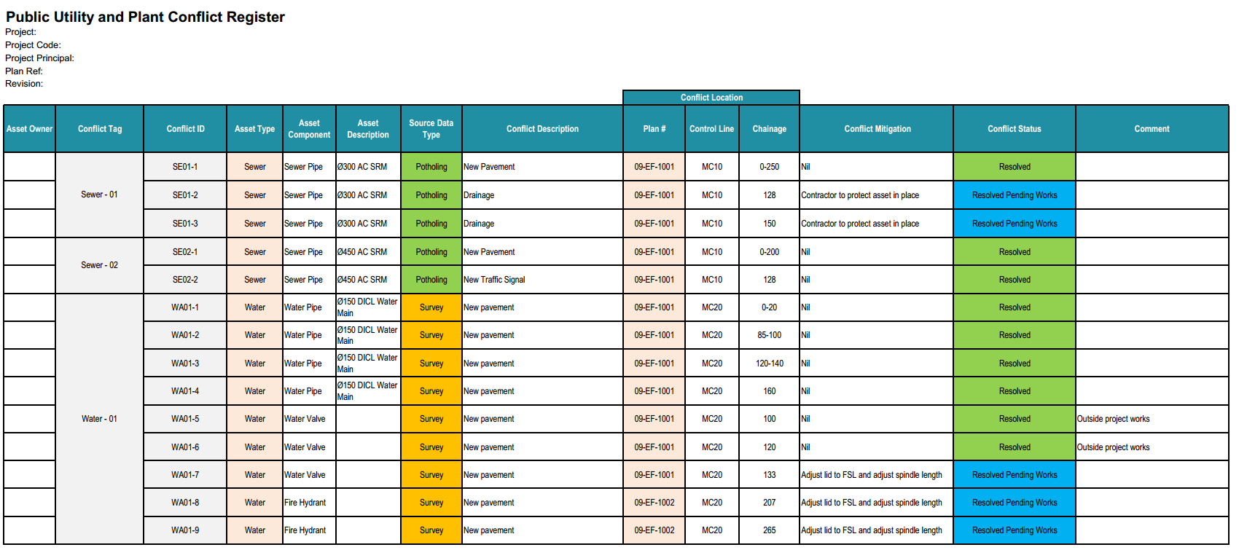

Appendix C – Application to undertake notifiable works
Application to undertake notifiable works
Submit application to: gcwconflictassessments@goldcoast.qld.gov.au
Project Phase:
Planning & Concept ☐ | Detailed Design ☐ | Construction ☐
Project Name:

Project / Works Location

Project / Works Description:

The following documents are enclosed in the Application
☐ Plans of the proposed works (required)
☐ A copy of potholing and survey investigation data in any of the following formats: AutoCAD file (2D or 3D); ArcGIS or MapInfo file; or Potholing surveyors mud map.
☐ Plans detailing the location of ‘City’ water & sewer infrastructure and conflicts (required)
☐ Long section plan of existing ‘City’ water & sewer infrastructure affected by notifiable works (required)
☐ Conflict register detailing each conflict and the proposed solution (required)
Either:
☐ Preliminary design and/or work method statements for conflict resolutions
Or:
☐ RPEQ Certified design and/or work method statements for conflict resolutions
Acknowledgement
I hereby confirm that I have read and understand the City of Gold Coast – Guidelines for working near water and sewer infrastructure, identified all City water & sewer infrastructure in my planed works area, determined all proposed notifiable work activities and taken all practical steps to eliminate conflicts with City water & sewer infrastructure.

Name:…………………………………………….Signed………………………………….Date…………………

Appendix D – Typical leak detection procedure

- Isolate main.
- Leave at background pressure for 10 minutes.
- Drop 200kPa below background pressure for 10 minutes.
- Pump up 100kPa above background pressure for 60 minutes.
- Measure make-up water at end of 60 minutes. The make-up water must be below an allowable limit.

Appendix E – Typical approval conditions drawings
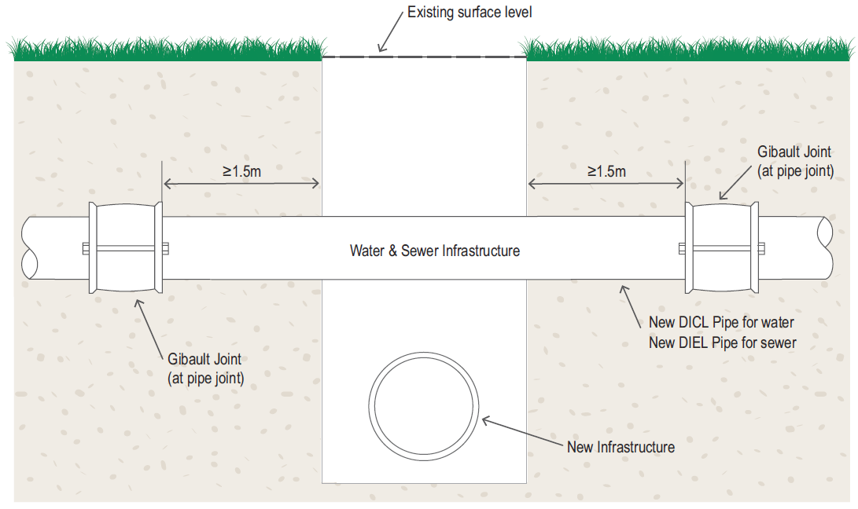
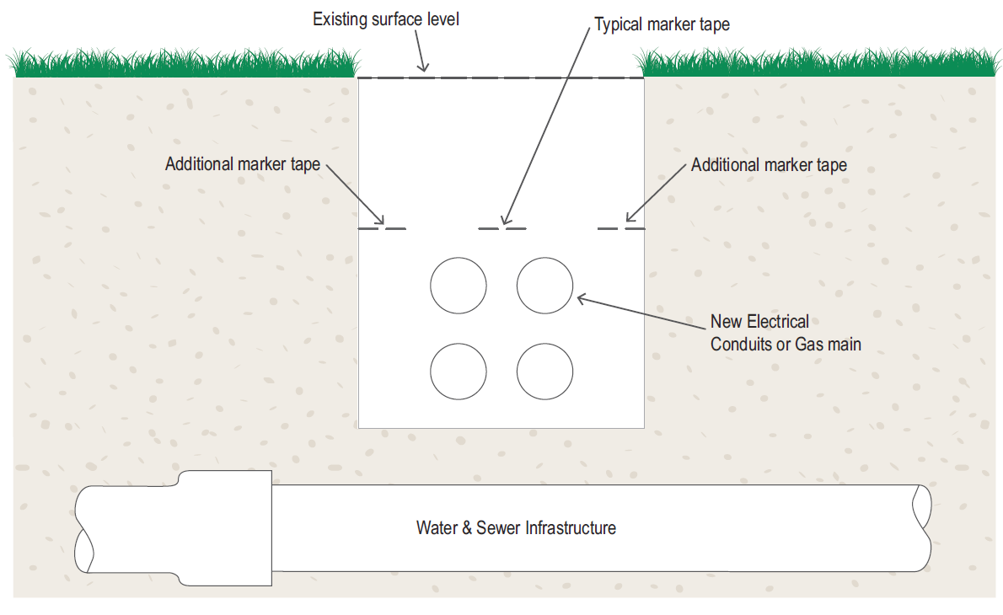

Appendix F – List of acronyms
Abbreviation | Definition
AC | Asbestos Cement
CICL | Cast Iron Cement Lined
DBYD | Dial Before You Dig
DICL | Ductile Iron Cement Lined
DIEL | Ductile Iron Epoxy Lined
FSL | Finished Surface Level
GCWW | Gold Coast Water and Waste
IPAM | Infrastructure Products and Materials
NMEC | Gold Coast Water Network Modifications, Extensions, and Connections Policy Procedure
PVC | Polyvinylchloride Plastic
RPEQ | Registered Professional Engineer of Queensland
SGM | Sewer Gravity Main
SRM | Sewer Rising Main
VC | Vitrified Clay
WSAA | Water Service Association of Australia (Water Supply Code of Australia)

Appendix G – List of definitions
 | Definition
Applicant | The party responsible for completing application forms and supplying the required documentation with the application and liaises with the City about notifiable works. The person could be the Developer, Consultant or Contractor.
Area of Influence | Area in which works are undertaken where ‘City’ water and sewer infrastructure will potentially be affected.
City | The City of Gold Coast and its appointed representatives
Clearance | The horizontal or vertical distance between two sets of infrastructure (i.e. the distance from the underside of a water main to the top of a sewer main crossing underneath).
Conflict | Any works that may potentially damage and or interfere with existing ‘City’ infrastructure; refer to Section 4 of this document.
Construction | Phase of a project where proposed works are physically undertaken on site.
Contractor | An internal or external entity responsible for undertaking the proposed works.
Cover | The vertical distance from the top of infrastructure to the ground (finished) surface level
Design | Phase of a project where the proposed works are developed and detailed
Ferrule | Valve located on the tapping at the connection of the water connection services to the supply main
Finished Surface Level | The final height (datum) of the ground after construction works have finished.
City water and sewer infrastructure | Any form of infrastructure owned by the City; pipelines, maintenance holes, valves, fire hydrants, meter boxes, pits, pump stations, cabinets, used in the supply and transfer of water and sewage owned by the City.
City surface infrastructure | All maintenance holes, valves, fire hydrants, meter boxes, pits and cabinets installed at the ground surface level and owned by the City.
Line of influence | The point at which works above, under or next to City water and sewer infrastructure affect the infrastructure.
Notifiable works | Any works undertaken near City water and sewer infrastructure as defined by Section 4 of this document.
Notifiable Zone | Area where works within would require a notification to the City.
Positive Identification of attributes | Confirmation of location and attributes by exposure of infrastructure, visual confirmation and direct measurement.
Project Stakeholder | A party that has any form of connection/interest in the project or works.
SEQ Code | SEQ design and construction code'
Service Connection | Water or sewer pipe connecting private property to City water and sewer mains

Appendix H – Document control form
Revision History
Revision # | Date | Prepared by | Reviewed by | Approved for Issue by
A | 14/07/2016 | SMEC Pty Ltd  (ISpot #57079438) | GCWW | GCWW
B | 02/08/2016 | C. Freeman. (ISpot #57256625v2) | GCWW | GCWW
C | 07/11/2016 | N. Pearson (ISpot #58645003) | GCWW | GCWW

For more information
P 1300 GOLDCOAST (1300 465 326)
W cityofgoldcoast.com.au

